**Umumta’lim maktabining 2024-2025-o‘quv yilining kimyo fanini o‘zlashtirish darajasini aniqlash uchun topshiriqlar**

**7-___sinf o‘quvchisi __________________________________________________**

**F.I.SH.**

**O‘quvchi to‘plagan umumiy ball:_____ (maksimal ball: 30)**

**IV chorak 7-BSB**

#### Qaysi metallar suv bilan reaksiyaga kirishib, vodorodni siqib chiqaradi?

#### .

1. Hg; 2) Na; 3) Mg; 4)Li; 5) Cu; 6) Al
2. Oksidlarning suvdagi eritmasi berilgan indikatorlarni qaysi ranglarga bo‘yashini to‘g‘ri yozing.

|  |  |  |  |
| --- | --- | --- | --- |
| **Oksidlarning suvdagi eritmasi** | **Indikator** | | |
| **Lakmus** | **Metiloranj** | **Fenolftalein** |
| P2O5 (kislotali eritma hosil qiladi) |  |  |  |
| CaO (ishqorli eritma hosil qiladi) |  |  |  |

1. Quyidagi eritmalar uchun erituvchi va eruvchi moddalarni yozing.

|  |  |  |
| --- | --- | --- |
| **Erituvchi** | **Eruvchi** | **Eritma** |
|  |  | osh tuzi etitmasi |
|  |  | sirka eritmasi |
|  |  | osh soda eritmasi |

1. **Neytrallanish reaksiyasi** – kislota va asos ta’sirlashuvidan suv va tuz hosil bo‘ladigan kimyoviy jarayon. Fe(OH)3 + H3PO4 →

Reaksiya tenglamasini yozing va reaksiyani tenglashtiring.

**____________________________________________________________________________________________________________________________________________**

1. Suvni tozalash jarayonining to‘rtinchi bosqichida suvga xlor qo‘shiladi. Nima sababdan suvga xlor qo‘shiladi?

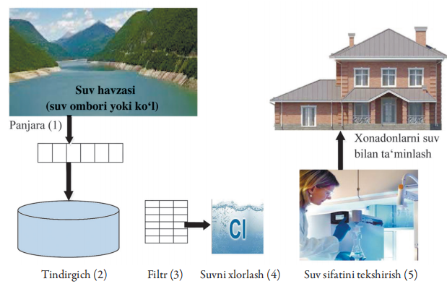

_______________________________________________________________________________________________________________________________________

**Baholash mezoni**

|  |  |  |
| --- | --- | --- |
| **Ball** | **To‘g‘ri javoblar** | **Baholash mezoni** |
| **3** | **2.3.4** | Har bir to‘g‘ri javob keltirilgan bo‘lsa 1 balldan beriladi  **3 ball** |
| **6** | |  |  |  |  | | --- | --- | --- | --- | | Oksidlarning suvdagi eritmasi | Indikator | | | | Lakmus | Metiloranj | Fenolftalein | | P2O5 (kislotali eritma hosil qiladi) | qizil | qizil | rangsiz | | CaO (ishqorli eritma hosil qiladi) | ko‘k | sariq | to‘q pushti | | Har to‘g‘ri javob uchun 2 balldan  **Jami: 12 ball** |
| **12** | |  |  |  | | --- | --- | --- | | Erituvchi | Eruvchi | Eritma | | suv | natriy xlor | osh tuzi etitmasi | | suv | sirka kislota | sirka eritmasi | | suv | natriy gidrokarbonat | osh soda eritmasi | | Har to‘g‘ri javob uchun 1 balldan  **Jami: 6 ball** |
| **4** | Fe(OH)3 + H3PO4 → FePO4 + 3H2O | Reaksiyani to‘g‘ri yozgan bo‘lsa 2 ball;  reaksiyani to‘g‘ri tenglashtirgan bo‘lsa 2 ball  **Jami: 4 ball** |
| **5** | Xlorlash – suvdagi organik qoldiqlarni oksidlash va dezinfeksiya qilish usuli. Bakteriya (mikrob yoki virus)larning yo‘q qilinishi uchun | To‘g‘ri javob keltirilgan bo‘lsa;  **5 ball** |
| **Jami** |  | **30 ball** |