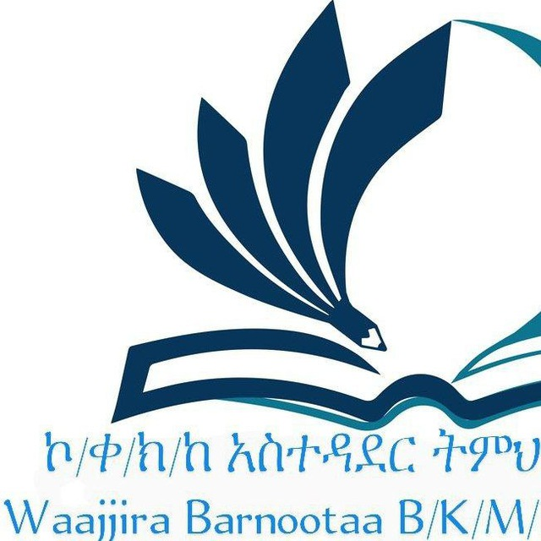 KOLFE KERANIO SUBCITY EDUCATION OFFICE
GENERAL SCIENCE MODEL EXAMINATION FOR GRADE EIGHT (8TH) 2016 E.C.
GENERAL DIRECTIONS:
THIS BOOKLET CONTAINS GENERAL SCIENCE EXAMINATION. IN THIS EXAMINATION, THERE ARE A TOTAL OF 60 MULTIPLE CHOICE QUESTIONS. CAREFULLY SELECT THE BEST ANSWER AND BLACKEN ONLY THE LETTER OF YOURE CHOICE ON THE SEPARATE ANSWER SHEET PROVIDED. FOLLOW THE INSTRUCTIONS ON THE ANSWER SHEET AND THE EXAMINATION PAPER CAREFULLY. USE ONLY PENCIL TO MARK YOUR ANSWERS. YOURE ANSWER MARK SHOULD BE HEAVY AND DARK, COVERING THE ANSWER SPACE COMPLETELY. PLEASE ERASE ALL UNNECESSARY MARKS COMPLETELY FROM YOURE ANSWER SHEET.
YOU ARE ALLOWED TO WORK ON THE EXAM FOR 1 HOUR. WHEN TIME IS CALLED, YOU MUST IMMEDIATELY STOP WORKING, PUT YOUR PENCIL DOWN, AND WAIT FOR FURTHER INSTRUCTIONS.
ANY FORM OF CHEATING OR AN ATTEMPT TO CHEAT IN THE EXAMINATION WILL RESULT IN AN AUTOMATIC DISMISSAL FROM THE EXAMINATION HALL AND CANCELLATION OF YOUR SCORE(S).
PLEASE MAKE SURE THAT YOU HAVE WRITTEN ALL THE REQUIRED INFORMATION ON THE ANSWER SHEET BEFORE YOU START TO WORK ON THE EXAMINATION.

DONOT TURN THIS PAGE UNTIL YOU ARE TOLD TO DO SO!!

DIRECTION ONE: CHOOSE THE CORRECT ANSWER FROM THE GIVEN ALTERNATIVES AND BLACKEN THE LETTER OF YOUR CHOICE ON THE ANSWER SHEET PROVIDED.
1. Which one of the following sets of indigenous measurement is used to measure only specific physical quantity?
A. Quntal, gram, tone C. Ruler, meter, foot
B. Digit, cubit, pace D. Kuntal, kilograms
2. If you learn 7 periods every day and each period has a total of 45 minutes. For how many minutes you learned in 5 days?
A. 26 hours C. 3150 minute
B. 1225 minute D. 1575 minutes
3. Which one of the following derived physical quantity is correctly matched with their units?
A. Mass➜ kilogram C. Length➜ ruler
B. Speed ➜m/s D. Time➜ watch
4. Which one of the following statement indicates the increasing order of prefix?
A. Centi, milli, kilo C. Deca, hector, kilo
B. Kilo, tera, nano D .Giga, mega, kilo
5. Take a candle & fix it on a table. Light the candle. Now cover the burning candle by putting an inverted gas jar over it. After a short time the candle stops burning & gets extinguished .which steps of scientific method is applied?
A. Test hypothesis C. Communication result
B. Formulated hypothesis D. Draw conclusion
6. One of the following statements is not true about hypothesis?
A. Hypothesis includes prediction that can be measured by experiments.
B. Null hypothesis is that we are accepted.
C. Alternative hypothesis that we are trying to prove.
D. We should create a new hypothesis, if it did not match with our expectation.
7. Which steps of scientific methods that allow other to verify your methods and results?
A. Ask question C. Test your hypothesis
B. Analysis the result D. Communication result
8. Which one of the following is not correct?
A. Nucleus is the heavy positive center of an atom. C. Protons are present in the atoms of all elements.
B. Neutrons are present in the atoms of all elements. D. Atoms are electrically neutral.
9. The number of protons, electrons and neutron in Zn²⁺are respectively.
- 30,28,35 C. 65,30,30
B. 30, 30, 35 D. 30,65,35
10. The idea that matter is discrete was proposed by:
- Plato C. Aristotle
B. Democritus D. Dalton
11. Which of the following elements exists as monoatomic molecule?
A. Nitrogen C. Neon
B. Ozone D. Chlorine
12. Which one of the following is true about vital force theory?
A. Organic compounds are the constituents of minerals.
B. Living things yields most inorganic compounds.
C. Organic compounds composed from living things.
D. In organic compounds composed from Hydrogen.
13. Which formula represents an alkane containing eight carbon atoms?
A. C₈H₈ C. C₈H₁₆
B. C₈H₁₈ D. C₈H₁₄
14. Which of the following is the first organic compound synthesized from inorganic compound?
- (NH₂)₂CO C. NH₄CNO
B. Ag CNO D.NH₄Cl
15. Which one of the following is basic oxide?
- Co₂ C. No₂
B. So₃ D. Mg O
16. Which of the following is not true about the properties of acids?
- They can be neutralizing bases to form salt and water.
- It releases hydroxide ions when dissolved in water.
- They have sour taste.
- It releases hydrogen ions when dissolved in water.
17. When a person accidentally drinks corrosive acid, his families have taken him to the nearest clinic. The doctor in the clinic carefully diagnoses his condition and prescribed a medicine that neutralize the acid in his body. What is the appropriate medicine the doctors has been prescribed so as to treat the patient?
A. Milk of magnesia Mg (OH)₂ C. Dilute KO
B. Dilute HCL D. Dilute Na OH

18. Which of the following salt is used to make gun powder and fertilizer?
- KNO₃ C. CaCO₃
B. NaHCO₃ D. MgSO₄
- what does `x` represent in the following reaction SO₃ +H₂O X
- H₂SO₃ C. H₂SO₄
B. SO₂ D. H₂S
- The white colored half-moon shaped of the nail is called:
A. Lunula C. Matrix
B. Cuticle D. Nail bed
- The outer most layer of the skin which is made up of dead cells that used to reduce excess water lose , protect from light ray and entry of disease causing microorganisms is:
- Epidermis C. Hypodermis
B. Dermis D. Cuticle
22. The skin disease caused by allergic reaction in the body and by outside factors such as stress, illness or tight clothes.
A. Acne C. Warts
B. Hives D. Chickenpox
- Among the following which type of gland located in ear canal and it produce ear wax?
- Sebaceous gland C. Mammary gland
B. Sudoriferous gland D. Ceruminous gland
- Assume your teacher gave you different types of bones to categorize them into groups. The bones were rib, hip, skull, shoulder and sternum. Which of these bones is grouped in axial skeleton?
A. Rib and shoulder C. Hip and shoulder
B. Rib and skull D. Hip and sternum
- Which one of the following muscles is correctly matched with its function?
A. Smooth muscle →contracts and moves blood in intestine.
B. Cardiac muscle →contracts and moves water in the body.
C. Skeletal muscle →contracts and moves blood in blood vessels.
D. Smooth muscle →contracts and moves food in intestine.
26. The type of respiratory disease causes air flow blockage and breathing related problem, mainly caused by smoking cigarette.
- Chronic obstructive pulmonary disease(COPD) C. Asthma
- Influenza D. Sinusitis
27. In which blood circulation system is blood flows between only heart and lung?
- Systemic circulation C. Double circulation
B. Pulmonary circulation D. Single circulation
28. Which of the following is the correct pathway of oxygenated blood flow?
- Lung→ pulmonary vein → left atrium → left ventricle → aorta→ body tissue.
- Vena cava→ right atrium→ right ventricle→ pulmonary artery→ lung.
- Body tissue→ aorta→ left ventricle→ left atrium→ pulmonary vein→ lung.
- Lung→ pulmonary artery→ right ventricle→ right atrium→ vena cava.
- The place where oxygen can reach the blood and carbon dioxide to be removed is:
- Alveoli B. Larynx C. Lung D. Pharynx
- The diagram below shows the female reproductive structures. Which number represented by "oviduct", Cervix and "womb" respectively?: A. 2,4,3 B. 1,2,3 C. 5,4,3 D. 3,4,2
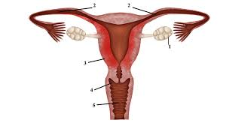
- On the above diagram, which number represented ovary?
A. 3 B. 2 C. 1 D. 5

- The students compare with other students in question and answers in order to get awards. Then this is what types of interactions?
A. mutualism C. parasitism
B. competition D. Proto cooperation
33. The type of biological interaction between in different species is called:
- Inter- specific interaction C. Symbiosis
- Intra-specific interaction D. Associations
34. Which of the following biological association is correctly matched with its characteristics?
A. Commensalism →one Species benefits, the other are affected.
B. Parasitism→ one Species benefits, the other is unaffected.
C. Mutualism→ both Species are benefits.
D. competition →both Species are affected.
35. The main deriving factor of oxygen cycle is the process of_____.
- Breathing C. Reproduction
B. Respiration D. Photosynthesis
36. Which one of the following is not included under In-situ conservation?
A. National Park C. Wild Life Sanctuary
B. Seed bank D. Biosphere Reserve
37. What is the primary consumer in the given food chain? (Grass → Mouse → Snake → Eagle).
A. Grass C. Snake
B. Mouse D. Eagle
38. On question 37 which organism has the lowest biSomass?
A. Grass C. Snake
B. Mouse D. Eagle
39. The correct direction of energy flow is:
A. Autotrophs→ primary consumer→ Secondary consumer → herbivores.
B. Producers → herbivores→ first consumer →Secondary Carnivores.
C. Producers→ herbivores→ First carnivores→ Secondary Carnivores.
D. Producers→ herbivores→ primary consumer→ Secondary consumer.
40. The reduction of nitrate back to inert nitrogen gas (N2) completing the nitrogen cycle is called:
A. Assimilation C. Nitrogen fixation
B. Nitrification D. De nitrification
41. The size distribution of the mineral particles found in a representative sample of soil is:
- Soil texture C. Soil fertility
B. Soil horizon D. Soil decline
42. The organisms that play great role in all nutrient cycle called:
A. Plant C. Herbivores
B. Producer D. Decomposer
43. A chemical that used to kill insects which damage plants:
- Herbicides C. Fungicides
B. Pesticides D. Antibiotics
44. Which one of the following is biotic component of an ecosystem?
- Soil C. Mineral rocks
B. Temperature D. Scavenger
45. Which planet tends to have the shortest time taken to make one complete revolution around the sun?
A. Mercury C. Earth
B. Venus D. Neptune
46. Which one of the following are not the characteristics of Jovian planets?
A. Outer planets have large diameter C. Jovian planets have low average densities.
B. Outer planets are made up of rocks D. Jovian planets have large number of moons.
47. Our earth is only known suitable place for life to exist because of many factors. One of the factors can be its:
A. Wide surface area C. Large vegetation covers
B. High temperature D. Right core
48. Suppose that the diameters of planets X are 49528km & that of planet Y is 12750km. What is the size of X- relative Y?
A. 0.948 C. 10.23
B. 0.257 D. 3.885
49. The fifth-largest planet in the solar system is:
A. Saturn C. Mars
B. Earth D. Neptune
50. Which one of the following is not correct about the formation of solar system?
A. Solar system formed a cloud of gas and dust.
B. The sun is found between the orbits of mars & Jupiter.
C. A shock wave from a nearby supernova explosion probably initiated the collapse of the solar nebula.
D. The cloud collapsed, possibly due to shock wave of nearby exploding star known as supernova.
51. The Ethiopian satellite that is launched on December 22, 2020 is:
A. ET-SMART-RSS C. SMART-RSS
B. ETRSS-1 D. ESAT
52. Nahom stands 12m away in front of a plane mirror, if Nahom walks away by 3m, now what the distance between Nahom and his image?
A. 30m C. 18m
B. 15m D. 24m
53. Which one of the following is correct about the image you see when you look at a plane mirror?
A. Real and the same size C. real and magnified
B. Virtual and the same size D. Virtual and magnified
54. A repeated sound that caused by reflection of sound waves from a surface is known as:
A. Reflection C. Echo
B. Refraction D. Dispersion
55. In which of the following media would sound travel faster?
A. Air C. water
B. Kerosene D. Iron
56. Which of the following mechanism of heat transfer can takes place in the absence of material medium?
A. Conduction C. Evaporation
B. Convection D. Radiation

57. We can pool a hot room by opening its window and letting in colder air, what method of heat transfer are we employing in cooling room?
A. Conduction C. Convection
B. Evaporation D. Temperature
58. Which one of the following is true about conductors?
A. Material that cannot pass current. C. Material that can allow light easily.
B. Material that current can pass through easily. D. Material that can allow light partially.
59. Which of the following can be picked up by a magnet?
A. Iron and steel C. Wood & clothes
B. Plastic and paper D. Aluminum & gold
60. Earth able to protected us from a harm full solar winds through it:
A. Magnetic field C. Atmosphere
B. Moon D. Amounts of liquid

