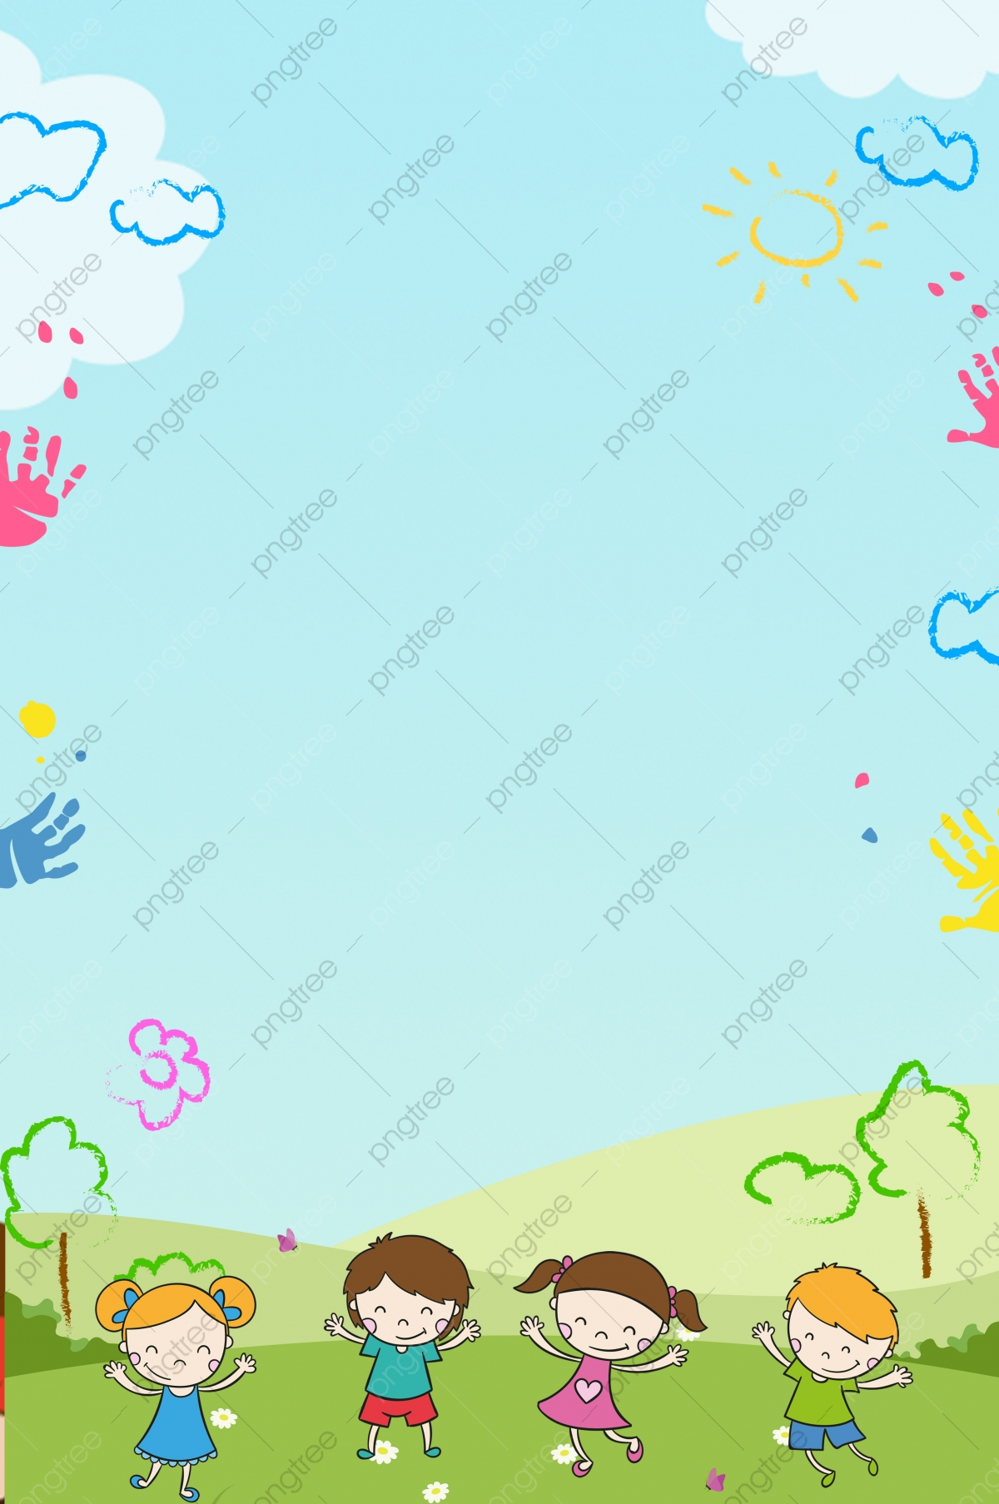

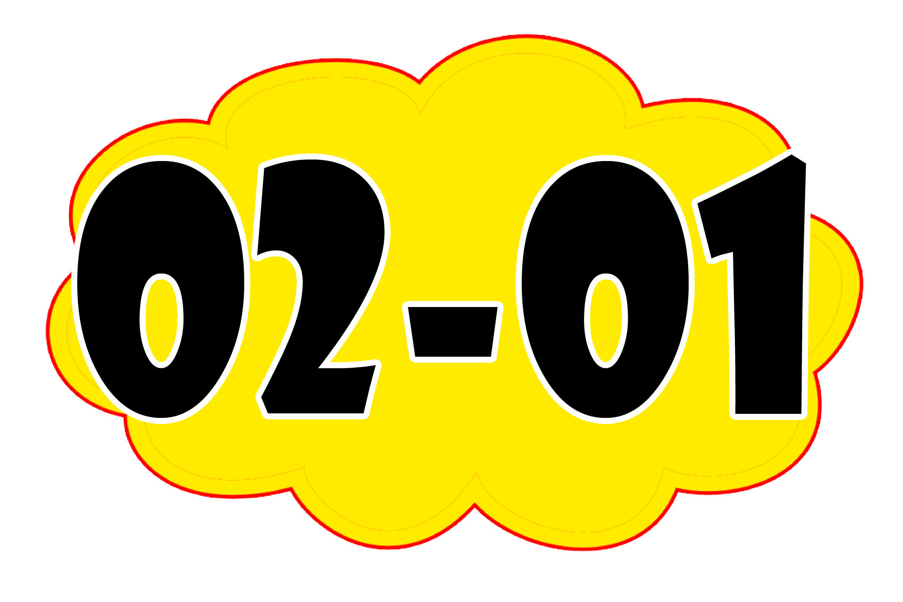

MAKTABGACHA VA MAKTAB TA’LIMI VAZIRLIGI

____________________________________________________
tuman (shahar) nomi
MAKTABGACHA TA’LIM BO‘LIMI TASARRUFIDAGI
____ - SONLI _________________________________
(agar ixtisoslashtirilgan bo‘lsa yoziladi)
MAKTABGACHA TA’LIM TASHKILOTINING


TARBIYALANUVCHILARNI MAKTABGACHA TA’LIM TASHKILOTIGA QABUL QILISH, GURUHDAN-GURUHGA O‘TKAZISH VA TASHKILOT RO‘YHATIDAN CHIQARISH TO‘G‘RISIDAGI

_______________________________________________________________________________________________________________________________________________________________________________________________________________________________________________________________________________________________________________________________________________________________________________________________________________________________________________________________________________________________________________________________________________________________________________________________________________________________________________________________________________________________________________________________________________________________________________________________________________________________________________________________________________________________________________________________________________________________________________________________________________________________________________________________________________________________________________________________________________________________________________________________________________________________________________________________________________________________________________________________________________________________________________________________________________________________________________________________________________________________________________________________________________________________________________________________________________________________________________________________________________
_______________________________________________________________________________________________________________________________________________________________________________________________________________________________________________________________________________________________________________________________________________________________________________________________________________________________________________________________________________________________________________________________________________________________________________________________________________________________________________________________________________________________________________________________________________________________________________________________________________________________________________________________________________________________________________________________________________________________________________________________________________________________________________________________________________________________________________________________________________________________________________________________________________________________________________________________________________________________________________________________________________________________________________________________________________________________________________________________________________________________________________________________________________________________________________________________________________________________________________________________________________

_______________________________________________________________________________________________________________________________________________________________________________________________________________________________________________________________________________________________________________________________________________________________________________________________________________________________________________________________________________________________________________________________________________________________________________________________________________________________________________________________________________________________________________________________________________________________________________________________________________________________________________________________________________________________________________________________________________________________________________________________________________________________________________________________________________________________________________________________________________________________________________________________________________________________________________________________________________________________________________________________________________________________________________________________________________________________________________________________________________________________________________________________________________________________________________________________________________________________________________________________________________
veb-saytimiz: Zokirjon.com
Zokirjon.com veb-saytimiz orqali o‘zingizga kerak bo‘lgan hujjatlarni yuklab oling.
Zokirjon Admin bilan
+99891-328-88-38 shu nomerdagi telegram orqali bog‘lanishingiz yoki jek567 izlab telegramga yozishingiz so‘raladi.
Telegramda murojaatingizga o‘z vaqtida javob beriladi

62 listdan iborat MTT buyruqlar kitobini to‘liq holda olish uchun telegramdan yozing.
Narxi: 10 ming so‘m
Telegram kanalimiz:
@maktabgacha_tt
To‘lov uchun: 9860230104973329
Plastik egasi Nabiyev Zokirjon

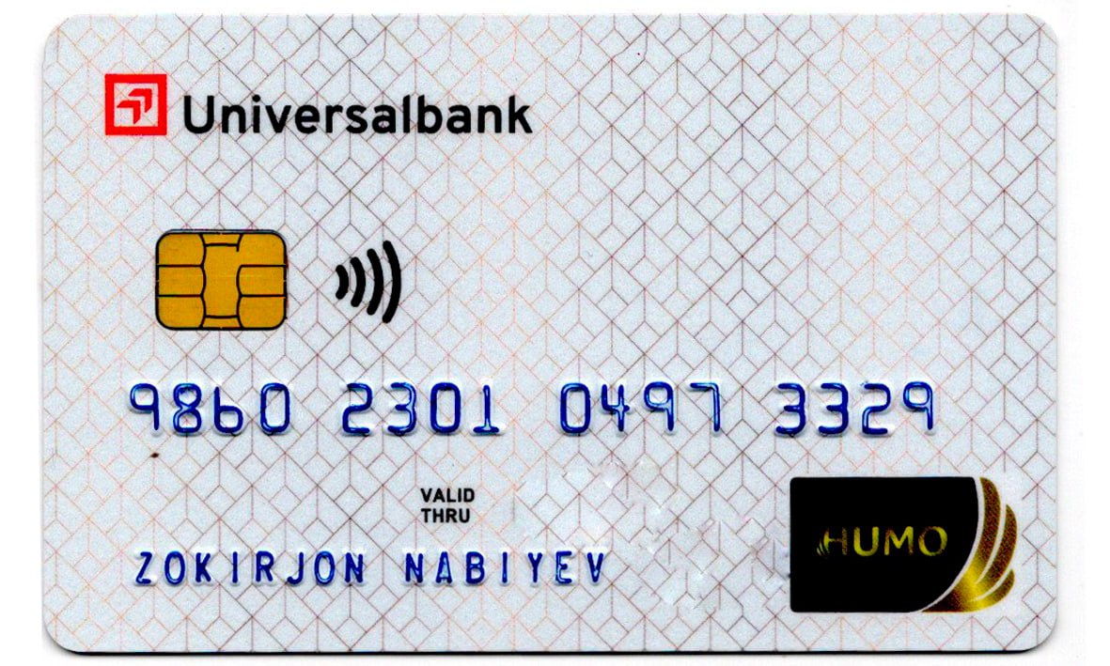
DIQQAT!!!
Sizga bu OMONAT qilib beriladi.
To‘liq holda olganingizdan so‘ng:
Faqat o‘zingiz uchun foydalaning.
Hech kimga bermang hattoki eng yaqin insoningizga ham.
Internet orqali veb-saytlarga joylamang.
Kanal va gruppalarga tarqatmang.
OMONATGA HIYONAT QILMANG.

