**Umumta’lim maktabining 2024-2025- o‘quv yili biologiya fanini o‘zlashtirish darajasini aniqlash uchun topshiriqlar varianti**

**8 -___ sinf o‘quvchisi ____________________________________F.I.SH.**

**O‘quvchi to‘plagan umumiy ball:_____ (maksimal ball: 40)**

**II– VARIANT**

**1-topshiriq (B)** Rasmdagi so‘roq o‘rniga pastdagi shakllardan mos keluvchisini toping.

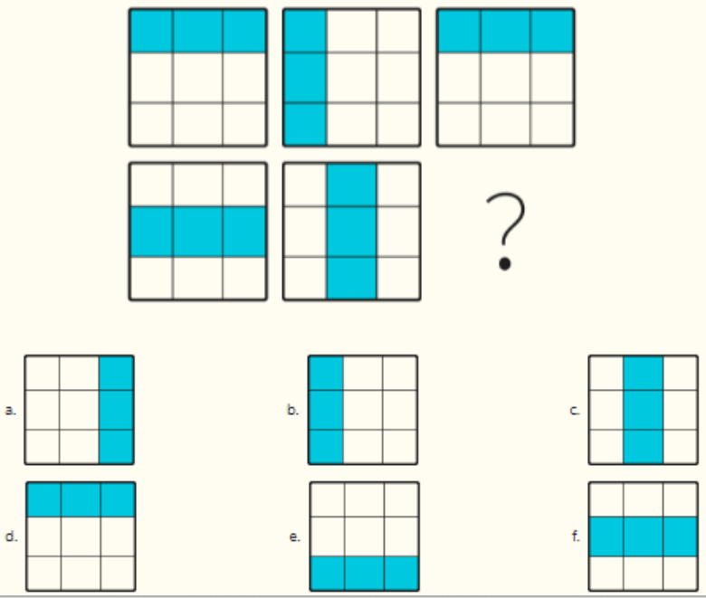

**2-topshiriq. (Q)** Pavlov bo‘yicha oily nerv faoliyati turiga ta’rif bering.

Fiziologik uyqu___________________________________________________________________

________________________________________________________________________________________________________________________________________________________________  
________________________________________________________________________________

Gipnotik uyqu____________________________________________________________________

________________________________________________________________________________________________________________________________________________________________  
________________________________________________________________________________

Narkotik uyqu____________________________________________________________________

________________________________________________________________________________  
________________________________________________________________________________

Letargik uyqu_____________________________________________________________________

________________________________________________________________________________  
________________________________________________________________________________

**3-topshiriq. (Q)**  Ortiqchasini toping va tagiga chizing.

1. Uyqusizlik, fiziologik uyqu, narkotik uyqu, gipnotik uyqu
2. Og‘zaki xotirasi, emotsional xotira, obrazli xotira, ixtiyorsiz xotira.
3. Flegmatik, nevroz, xolerik, melanxolik.
4. Diktorlik, o‘qituvchilik, raqqosalik, lektorlik
5. Kulgu, rohatlanish, quvonch, qayg‘u.

**4-topshiriq. (Q)** Tushib qolgan so‘zlarni to‘ldiring.

1) Nevroz, bu_____________________________________________________________________

2) Oliy nerv faoliyatining muvozanatlashgan tipiga_______________________________________ kiradi.

3) ______________________vaqtida moddalar almashinuvi va tana harorati pasayadi, muskullar bo‘shashadi.

4) Xotira ______________va _______________________________________bo‘ladi.

5) Yozma nutqning shakllanishi bosh miyaning_________________________________bilan bog‘liq.

**5-topshiriq. (M)** Bildirilgan fikrlarga to‘g‘ri yoki noto‘g‘ri javobini yozing.

|  |  |  |
| --- | --- | --- |
| **N** | **Bildirilgan fikrlar** | **to‘g‘ri/noto‘g‘ri** |
| 1. | Piyodalar uchun svetofor chirog‘i yashil yonganda yo‘lovchilarning harakatlanishi shartli refleks. |  |
| 2. | Uxlab yotgan Toxir tez-tez va chuqur nafas ola boshladi, chunki u tez uyqu fazasida. |  |
| 3. | Talaba bo‘lganini eshitgan abiturient hursandchiligi manfiy hissiyotga kiradi. |  |
| 4. | Rassomlarda obrazli xotira bosh miya yarim sharlari po‘stlog‘ining tepa qismi bilan bog‘liq. |  |
| 5. | Diktorlarda og‘zaki nutq yaxshi rivojlangan bo‘ladi. |  |

***Baholash mezoni***

|  |  |  |
| --- | --- | --- |
| **Ball** | **To‘g‘ri javob** | **Deskriptor** |
| **2** | Rasmdagi shaklni to‘g‘ri topsa  f javob | jami 2 **ball** |
| **8** | To‘g‘ri va to‘liq javob bersa  **Fiziologik uyqu** – sutka davomidagi normal uyqu, odam yoshi va holatiga qarab turli vaqt davom etadi;  **Gipnotik uyqu** – boshqa odam yoki gipnoz ta’sirida yuzaga keladigan uyqu. Gipnoz ta’sirida yarimsharlar po‘stlog‘idagi ayrim nerv markazlari tormozlanadi;  **Narkotik uyqu** – turli kimyoviy moddalar ta’sirida nerv markazlarida tormozlanish sodir bo‘ladi;  **Letargik uyqu** - kuchli qo‘zg‘alish yoki tormozlanish tufayli vujudga keladigan uyqu. Bir necha soat, kun, xafta yoki yillab davom etishi mumkin; | Har bir to‘g‘ri javob yozilgan qator  2 balldan jami 8 **ball** |
| **5** | 1. Uyqusizlik, fiziologik uyqu, narkotik uyqu, gipnotik uyqu 2. Og‘zaki xotira, emotsional xotira, obrazli xotira, ixtiyorsiz xotira. 3. Flegmatik, nevroz, xolerik, melanxolik. 4. Diktorlik, o‘qituvchilik, raqqosalik, lektorlik 5. Kulgu, rohatlanish, quvonch, qayg‘u. | Har bir to‘g‘ri javob  1 balldan jami **5 ball** |
| **10** | 1) Nevroz, bu oliy nerv faoliyatining buzilishi bilan bog‘liq og‘ir ruhiy xastalik.  2) Oliy nerv faoliyatining muvozanatlashgan tipiga sangvinik va flegmatik tip kiradi.  3) Sekin uyqu vaqtida moddalar almashinuvi va tana harorati pasayadi, muskullar bo‘shashadi.  4) Xotira uzoq va qisqa muddatli bo‘ladi.  5) Yozma nutqning shakllanishi bosh miyaning chap yarimsharlari peshona va ensa qismi bilan bog‘liq. | Har bir to‘g‘ri javob  2 balldan jami **10 ball** |
| **15** | Berilgan fikrlarni to‘g‘ri tahlil qilsa   |  |  |  | | --- | --- | --- | | **N** | **Bildirilgan fikrlar** | **to‘g‘ri/**  **noto‘g‘ri** | | 1. | Piyodalar uchun svetofor chirog‘i yashil yonganda yo‘lovchilarning harakatlanishi shartli refleks. | to‘g‘ri | | 2. | Uxlab yotgan Toxir tez-tez va chuqur nafas ola boshladi, chunki u tez uyqu fazasida. | to‘g‘ri | | 3. | Talaba bo‘lganini eshitgan abiturient hursandchiligi manfiy hissiyotga kiradi. | noto‘g‘ri | | 4. | Rassomlarda obrazli xotira bosh miya yarim sharlari po‘stlog‘ining tepa qismi bilan bog‘liq. | noto‘g‘ri | | 5. | Diktorlarda og‘zaki nutq yaxshi rivojlangan bo‘ladi. | to‘g‘ri | | Har bir to‘g‘ri javob 3 balldan jami 1**5 ball** |
| **Jami 40 ball** |  |  |