**Reading Comprehension:** **MY TRIP TO LONDON**

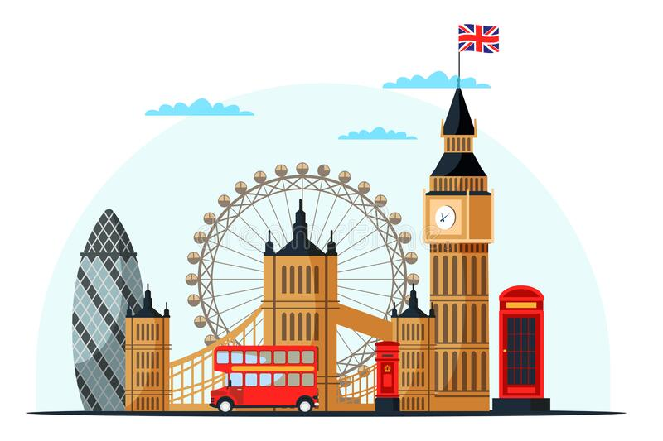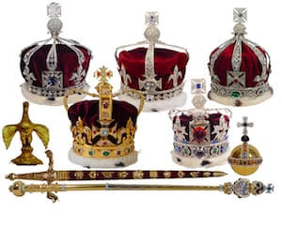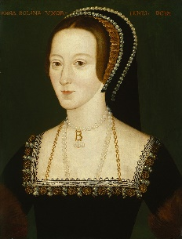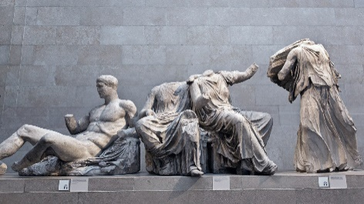**I live in Leeds, in the north of England. Last month, I went to London. I stayed for two nights. I arrived on Monday afternoon and left on Wednesday afternoon. I stayed in a hotel near to the Tower of London. I went by train. It was fast and very convenient. I visited the Tower. I saw the Crown Jewels. I also saw the place where famous people, including a queen of England, Anne Boleyn, were beheaded. I had a trip to the British Museum. I wanted to see the Elgin marbles. The Elgin marbles are Greek sculptures. They were at the Parthenon in Athens, the capital of Greece, but a British man, Lord Elgin, brought them to Britain in 1816. Sadly, when I arrived, the Elgin Marble rooms were closed! Disappointing, but there was plenty other stuff to see. On Tuesday evening, I went to a show. It was ‘The Windsors’ – a comedy about the royal family. I didn’t think it was funny, so I left at the interval. I ate at Brasserie Cote on Monday night and then on Tuesday night, I had fish and chips. I sat beside Tower Bridge and ate them while watching the world go by. The weather was fine, so I had a long walk along the Thames and I saw some famous sites. There are many Roman remains in London. The old sits comfortably next to the new and modern. Everyone was very friendly. I had a great stay and I would like to return soon. By Lou.**

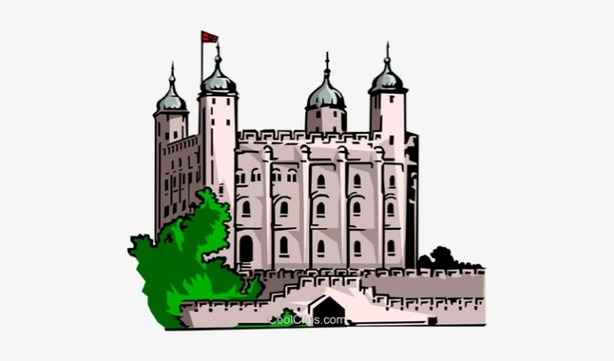***Answer the following questions in full sentences:***

1. **Where does Lou live? _________________________________**
2. **Where did she go? ___________________________________**
3. **How did she travel? __________________________________**
4. **When did she arrive? _________________________________**
5. **When did she leave London? ____________________________**
6. **How long did she stay? ________________________________**
7. **Where did she stay? __________________________________**
8. **Which jewels did she see at the Tower? ___________________**
9. **Why did she go to The British Museum? ____________________**

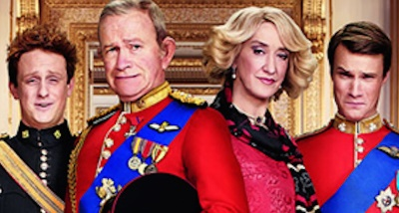**10. Why didn’t she see the Marbles? _________________________**

**11. Who brought the Marbles to Britain? _____________________**

**12. When did he bring them? ______________________________**

**13. What show did Lou go and see? _________________________**

**14. Why did she leave at the interval? _______________________**

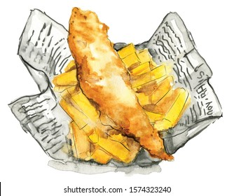**15. What did she have to eat on Tuesday night? _________________**

**16. What was the weather like? _____________________________**

**17. Where did she go walking? _______________________________**

**18. How did she find the people? _____________________________**

**19. How do the old and the new sit together in London? ___________**

**20. Does Lou want to return? _______________________________**

***Say something about each image.***

***Have you been to London? What did you see? If not, would you like to go?***

**KEY**

1. She lives in Leeds
2. She went to London
3. She travelled by train
4. She arrived on Monday afternoon
5. She left on Wednesday afternoon.
6. She stayed (for) two nights.
7. She stayed at a hotel near the Tower.
8. She saw the Crown Jewels.
9. She went to see the Elgin marbles
10. The Elgin Marbles rooms were closed.
11. Lord Elgin brought them to Britain./Lord Elgin did.
12. He brought them in 1816.
13. She went to see ‘the Windsors’.
14. She thought it wasn’t very funny./She didn’t think it was very funny.
15. She had fish and chips.
16. It was fine.
17. She walked along the River Thames.
18. She found them very friendly
19. They sit together very comfortably.
20. Yes, she does./She wants to return.

**The images.**

A clipart of London, showing Tower Bridge, the London Eye, Big Ben, a telephone box, a bus, the Gherkin.

The Crown Jewels, a fabulous collection of royal jewellery and crowns, housed in the Tower of London

Anne Boleyn, second wife of Henry 8th, beheaded after being accused of treason.

The Elgin Marbles – Greek sculptures.

The Tower of London. It is a very old building, on the banks of the Thames.

The cast of ‘the Windsors’, a satirical show based on the British Royal family.

Fish and chips, wrapped in newspaper.

* I have been to London. I saw/visited……………….
* I haven’t been to London. I would like/wouldn’t like to go.